**Personal Learning Plan**

Delivery Date: 13th of November – 2016

Subject: Web Design – Photos

Strengths: Enjoy coding

Weaknesses: Lack of free time

1. **SPECIFIC:**

I will develop the second page of the navigation bar called “PHOTOS”. After the user has read the basic informations about our product in the home page, its time to visulalise the product. In this page the customer will see how the product works and possibilities of customisation through images.

It will require images of the kites flying, of materials, of the product and of the customer using our products.

In the image below we can see the wireframe of what needs to be achieved.

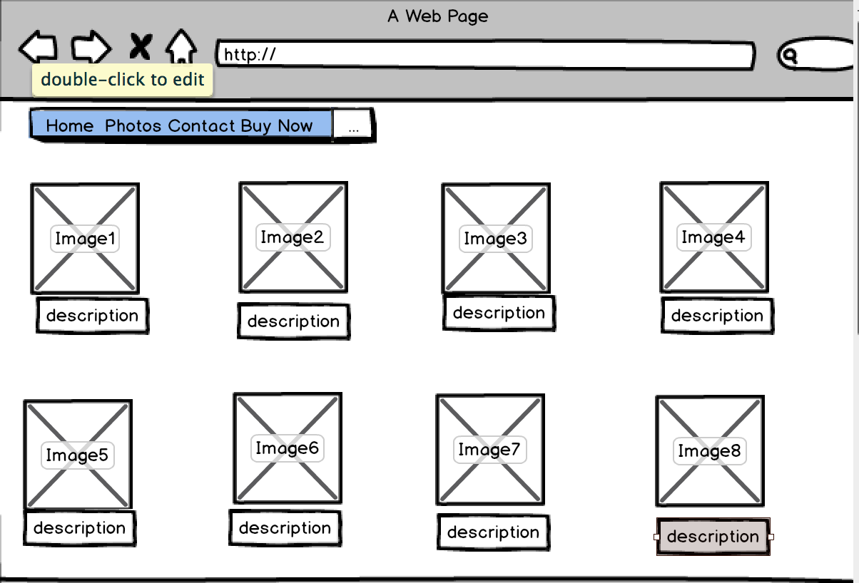

1. **MEASURABLE:**

Develop the PHOTOS page will take 8 images with a description in all of them. It should take about 3-4 hours of work using HTML and CSS only. Also will have a background image and the general colours of the page will be black, grey, and white. But the images will have its original colours and a Red headline introducing the images.

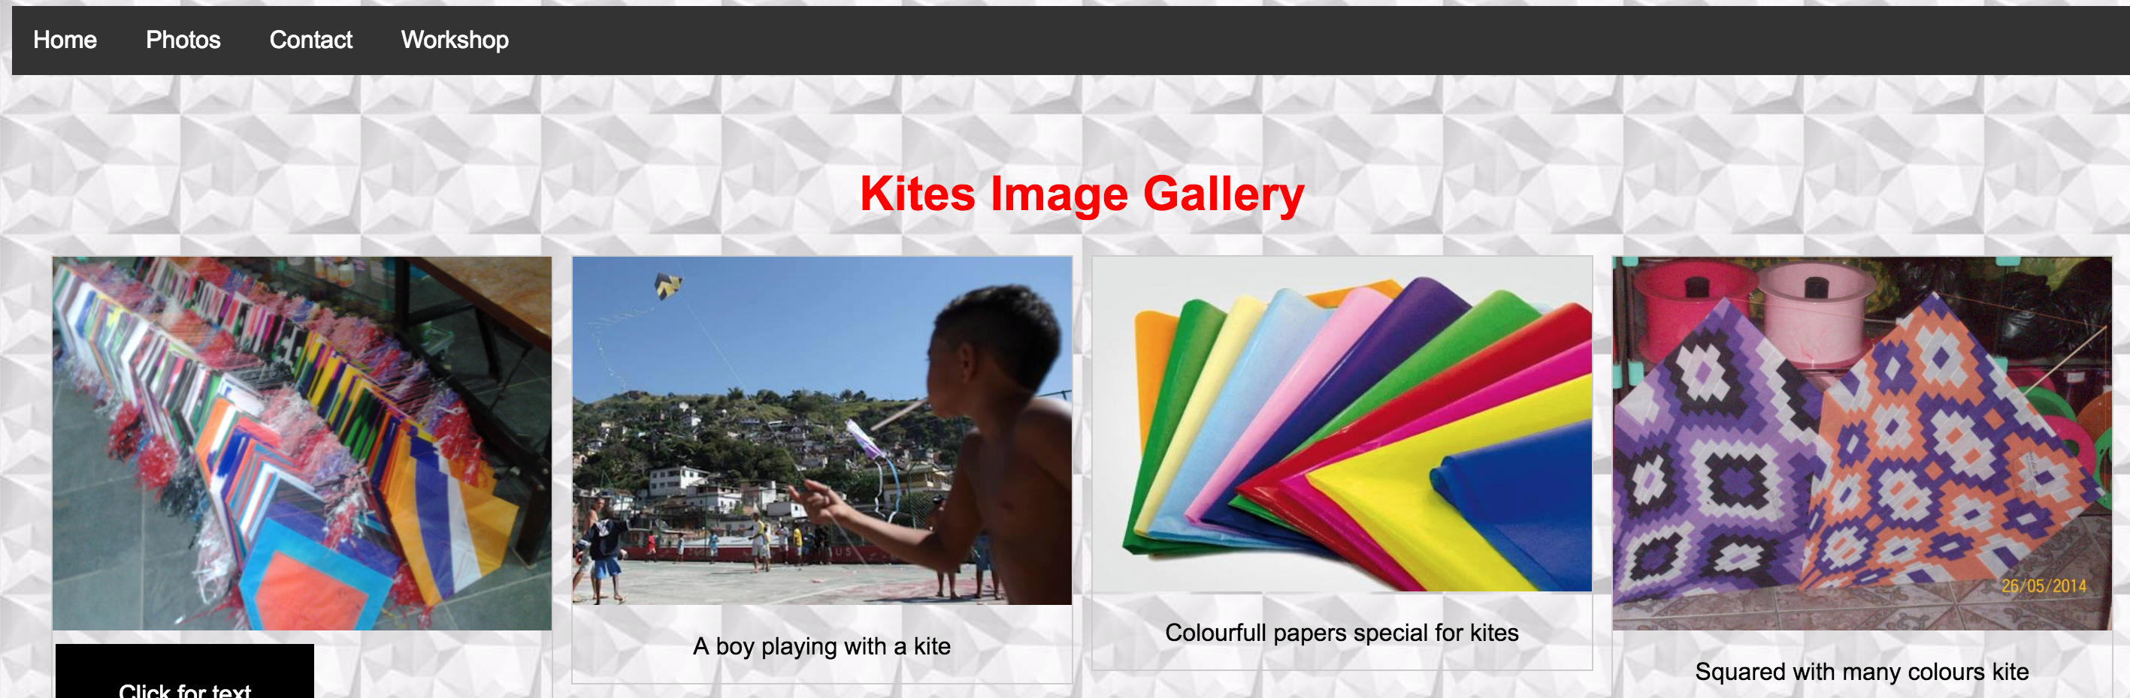

In the image above we can see the structure of and more images to be added within a description.

1. **ACHIEVABLE:**

The goal is to have the user visualising the product, catching the user’s curiosity or interest leading him to our 3rd page (Buy Now) where deals can be closed.

1. **RELEVANT:**

Having users visualizing the product after reading about it, will increase the chances of leading the user to our 3rd page where deals can be closed.

1. **TIME-BOUND:**

Having 2 people visiting the Photos page per week, improving the chances of having at least a new client per month. This page should take from 3 to 4 hours to be built.

The deadline for the second page is the 13th of November.